

|  |
| --- |
| Guide to applying for a movable unit |
|  |

Contents

About movable units 2

Being eligible 2

Features 2

Who can apply 3

How to fill out the application 3

Application for a movable unit sections 4

Section A: Property host – about you 4

Section B: Privacy and this application 4

Section C: Additional property host 4

Section D: About your property 4

Section E: Movable unit type – property preferences 5

Section F: Applicant – about the occupant of the movable unit 7

Section G: Information about the applicant’s income and assets 7

Section H: Support 7

Section I: Centrelink Confirmation eServices (CCeS) 7

Section J: Entering into a hiring agreement 8

Section K: Household member 8

Special accommodation requirements 8

Other important information 9

Next steps 9

Hiring agreement 9

Costs 9

Insurance and maintenance 9

Unit completion and tenancy commencement 9

Transfers 10

Vacating a unit and unit removal 10

Need more information on movable units? 10

Income information and documents 11

Using Centrelink Confirmation eServices (CCeS)? 11

Not using CCeS? 11

Asset information and documents 13

Using CCeS? 13

Not using CCeS? 13

Bank accounts 13

Investments 13

Land and property 13

Language Link 14

# About movable units

Movable units are self-contained units that can be set up in a friend’s or relative’s backyard.

It usually takes three to six months to construct a unit once an application has been approved.

Movable units will only be built on sites where the main house is occupied.

They cannot be attached to the main house or any other structure.

# Being eligible

In general, to be eligible for a movable unit the property that is hosting the unit must be suitable and the applicant who will be living in the unit must:

* be a permanent Australian resident who is:
  + - over 55 years of age, or
    - receiving at least $1 of an Australian Disability Support Pension, or
      * receiving ongoing support from the Department of Health and Human Services or a registered community service organisation
* meet the eligibility criteria for the Victorian Housing Register (the register) – Register of interest and transfer income and asset limits
  + agree to repay any money owed from a previous public housing tenancy or bond loan.

The units are not allocated to organisations or for the purpose of group housing.

# Features

Movable units include a bedroom, an ensuite bathroom, toilet and laundry, and a living room with an annexe kitchen.

They are built with timber frames or panel construction, with a flat, insulated metal roof.

The external walls are constructed of either cement or metal sheeting, which is insulated.

The inside walls are constructed of either cement sheeting or plaster board.

The fittings include:

* vinyl floors in the kitchen and bathroom
* carpet in the living room and bedroom
* a bathroom with shower only (no bath), hand-held shower rose and grab rails
* a stove, heater and hot water service
  + hot and cold washing machine taps and a capped waste outlet. There is no laundry trough.

Movable units can also be fitted with additional grab rails, an entrance ramp and other (non-structural) modifications if medical documents confirm a need for these.

Most units are one-bedroom; however, there are a limited number of two-bedroom units available.

The units may be new or they may have been moved from another site. Movable units that have been moved are refurbished at each new location.

They can be dismantled and carried through a relatively narrow access point when they are being installed and removed.

# Who can apply

These people are involved in a movable unit application:

* **Property host** – the person who lives in the main house where the movable unit will be. They can own or rent the house or live in social housing. The property host is the person who owns the application, and is submitting the application on the applicant’s behalf.
  + **Applicant** – the person who will live in the unit.

There may also be **additional property host(s)** who share ownership of the main house, or a **household member** who will live with the applicant.

# How to fill out the application

The steps to follow:

1. There are 11 sections in the Application for a movable unit to be filled in (Sections A to K).
2. The **property host completes Sections A to E, and J.**
3. The **applicant completes Sections F to I.**
4. Attach the documents required by the department.

 As you fill in the form, you will see a symbol of a piece of paper with a paperclip. It is there to tell you what other documents you may need to give us in some situations.

Page two of the application tells you about most of the documents the property host, applicant and additional household member (if there is one) will need to provide.

As you move through the application, the department may ask for additional documents.

1. Make sure that all property host(s) and the applicant sign the ‘Declaration, acknowledgement and consent’ in Section J.
2. If the applicant needs any changes to the property, make sure that an *Application for special accommodation requirements* is completed. The applicant and their treating health practitioner fill in this form.
3. Submit any Application for special accommodation requirements with the application for a movable unit.
4. Complete the checklist in Section J of the form to make sure your application is complete.

It is important to give the department all the information and documents requested, or it may take longer to assess or process your application.

The department will write to the property host within 14 days of when the application is received to advise if the application has been approved or to ask for further documentation or information, if needed.

# Application for a movable unit sections

## Section A: Property host – about you

This section asks for the property host’s personal information including their name, date of birth, gender, contact details, preferred language and whether they need an interpreter.

The property host is the owner of the application and will receive all communication about it.

## Section B: Privacy and this application

This section asks about any support or advocacy you may be getting from an individual or organisation, and whether you give permission for the department to discuss your application with them.

This includes if you would like the department to speak to a family member or friend about your application.

## Section C: Additional property host

This section asks the property host if anyone else is listed on the:

* property title - if you own the property where the unit will be located, or
  + tenancy agreement - if you rent.

Please provide their name, date of birth, gender, postal address and contact details.

If there are more than two property hosts, include:

* an additional Section C and
  + a signed statement confirming their permission for the unit to be installed on the property.

## Section D: About your property

This section asks about the property where the unit will be installed.

Private owners or tenants of a private owner will need to give the department:

* **a current copy of the certificate of title** – this shows the property’s owner, plan of subdivision and any covenants or caveats. Details of caveats must also be provided.
* If the owner has recently bought the property and their name is not yet on the title, they need to provide settlement documents. Note: the department cannot approve an application until **after** settlement has occurred.
  + **a copy of the property sewerage** **plan** – this will have a plan number on it and is available from the local water authority.

If the house has a septic system, you must provide:

* written advice from the council that a unit can be connected to the existing system, or
  + written confirmation that the property post will pay if the system needs an upgrade to accommodate the unit.

If you already have a movable unit on your property, you do not need to provide these documents.

If you are renting the property where the unit will be installed, you will also need to provide:

* + written consent from the owner - saying the movable unit can be built on the property and that the owner acknowledges the movable unit remains the property of the Director of Housing.

The department will need to contact the owner and/or landlord of the property to discuss the application with them.

## Section E: Movable unit type – property preferences

Movable units come in different sizes, shapes and amenities. They also come with different types of entrances. Various types of disability modifications can be installed too.

### Number of bedrooms (question E1)

Movable units can have one or two bedrooms.

A single person or couple will usually only be eligible for a one-bedroom unit. A request for a two-bedroom unit may be approved if it is supported by a completed application for special housing requirements.

### Building shape preference for one-bedroom movable unit (question E2)

There are two different floor plans to choose from:

* rectangular unit of about 8 metres by 5 metres
  + square unit of about 6 metres by 6 metres.

The internal layout of units can vary slightly and will also depend on any site constraints.

Figure 1. A rectangular unit of about 8 metres by 5 metres

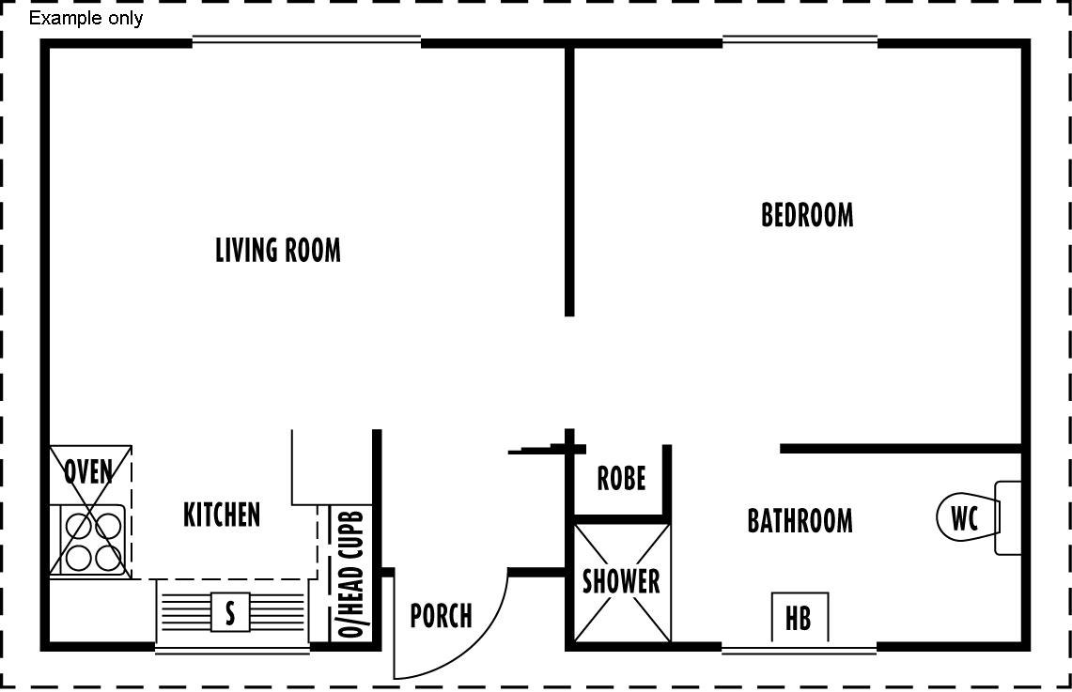

Figure 2. A square unit of about 6 metres by 6 metres

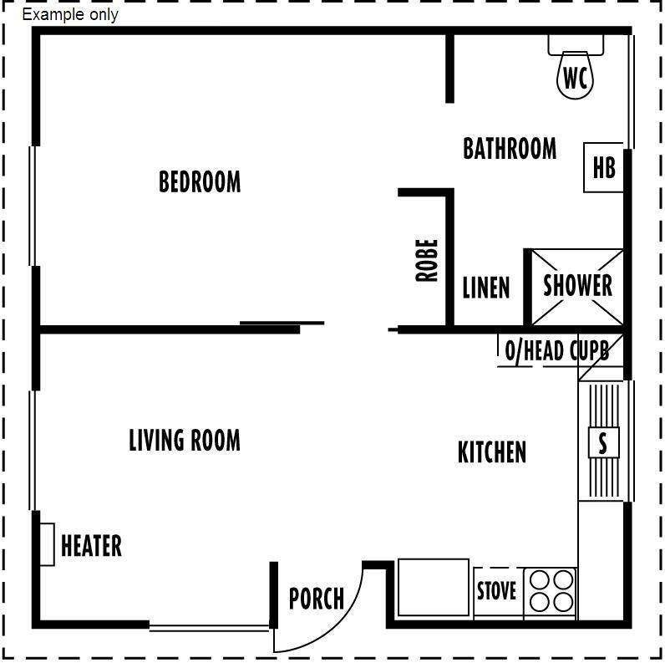

### Appliance preference (question E3)

You are able to choose whether you want the unit’s stove, heater and hot water service to run on electricity, LPG or natural gas (providing a gas connection already exists on site).

### Steps or ramp access (question E4)

Units usually have a number of entrance steps. In this section you must explain whether the applicant or household member will be able to access the unit using steps or if they need a ramp to be installed.

**Note:** Inclusion of a ramp will increase the area needed on your property for the unit.

If a ramp is required, the applicant’s treating health practitioner must complete an application for special accommodation requirements.

It is important for the applicant to tell the department on their application about any special accommodation requirements so the right type of unit can be selected.

Some special accommodation requirements cannot be accommodated in standard units. If these requirements are applied for after construction, the unit may need to be removed. Depending on the site, it may not be possible to replace the unit once it is removed.

## Section F: Applicant – about the occupant of the movable unit

This section asks for the applicant’s personal information including their name, date of birth, gender, marital status, contact details, residency status, preferred language and whether they need an interpreter.

If the applicant has already given this information as part of a current Victorian Housing Register application they do not need to give it again.

If the application also has current information about their income and assets, they need to provide the reference number of their Victorian Housing Register application.

## Section G: Information about the applicant’s income and assets

This section asks about the money the applicant receives and the assets they own.

If the applicant has a Victorian Housing Register application with current information about their income and assets, they do not need to complete this section.

If the applicant is currently receiving a payment from Centrelink, they can choose to:

* give the department information and documents to confirm their income and assets, or
  + allow the department to get this information directly from Centrelink via Centrelink Confirmation eServices (CCeS).

See **Section I** of this guide for more information about CCeS.

If not using CCeS, the applicant will have to give the department documents to confirm their income and assets. See ‘Income information and documents’ on page 8 of this guide for more on documents that might be needed.

**Note:**

* The department is interested in all types of income received from any source.
* Assets generally include money in the bank, shares, mobile homes, real estate, businesses and so on.
* Assets may include superannuation funds if they can be accessed.
  + Assets generally do not include personal belongings, a car or furniture.

## Section H: Support

This section asks the applicant whether they would like the department to contact their support person or advocate to discuss the application. It also asks whether they give permission to the department to make such contact.

If applicable, ask the applicant to speak to their support person or organisation before deciding whether they want copies of all letters the department is sending to them to be sent to the support person or organisation as well.

Some may not wish to receive copies of correspondence if it has not been discussed first.

## Section I: Centrelink Confirmation eServices (CCeS)

CCeS is an online service that allows the department to obtain information directly from Centrelink, to confirm your eligibility for housing services.

It is recommended that you use CCeS if you are a Centrelink customer as the department periodically requires up-to-date information about your income and assets to confirm your eligibility for housing services.

CCeS has strict privacy and security standards and the department must have your consent before obtaining information about you.

The applicant can provide consent by signing the ‘Consent to use Centrelink Confirmation eServices (CCeS)’ in **Section I** of the application. If there is an extra household member, they can also provide consent in that section.

Once the consent form is signed, the department can use CCeS to obtain information about your income and assets directly from Centrelink. This means you will not need to tell the department about your income or assets (apart from lump sum payments).

This will make it easier for you and quicker for the department to assess your eligibility for housing services.

## Section J: Entering into a hiring agreement

The terms and conditions for hiring a movable unit are included in the hiring agreement.

A hiring agreement is signed after the application is assessed and eligibility (including site checks) has been established.

It is important you understand the hiring agreement. It explains any costs you may have to pay and important information about managing the unit.

The property host and applicant must sign the hiring agreement to say they understand and agree to the terms and conditions before a movable unit can be constructed.

This section of the application also gives an overview of the terms and conditions from the hiring agreement.

## Section K: Household member

You only need to complete this section of the application if another person will be living with the applicant.

Any additional household member will be asked to answer many of the same questions, and provide many of the same documents as the applicant.

# Special accommodation requirements

If a movable unit has to be modified because of an applicant’s special accommodation requirements, these will need to be shown in an Application for special accommodation requirements.

Examples of special accommodation requirements include:

* a unit with an access ramp because of limited mobility or a medical condition
* minor modification such as grab rails or lever taps
* major modifications such as work to make a property wheelchair accessible
  + an additional bedroom because of a specific medical need.

The **Application for special accommodation requirements** must be:

* completed by both the applicant and their treating health practitioner
* returned with the movable unit application.

# Other important information

## Next steps

If the application is approved, the department will contact the property host to arrange a site inspection and to talk about where to build the unit.

If the site is suitable for a movable unit, the department will prepare a site plan and hiring agreement for the property host to sign and return.

## Hiring agreement

The hiring agreement sets out the terms and conditions, and the responsibilities and obligations of the property host, the applicant and the Director of Housing.

By signing the agreement, the applicant agrees to pay the hiring fee for at least 12 months. If the applicant leaves earlier than this, the applicant and the property host could face costs for the remaining period left on the agreement. If the applicant or property host ends the agreement before the hiring of the unit starts, costs associated with permits, construction and removal of the unit may be charged.

In circumstances where the applicant passes away or needs to be hospitalised within the first 12 months, the 12-month hire charge may be waived.

## Costs

The applicant of a movable unit must agree to pay the weekly or fortnightly hire charge. The minimum term is 12 months. The amount the applicant needs to pay will depend on their income.

If the applicant is eligible for a rental rebate, the cost will be either 25 per cent of their income or the weekly or fortnightly hire charge, whichever is less.

For a private property, the property host is responsible for meeting the costs of upgrading any utility service (if required), and clearing the site before construction of the unit. This includes trees, structures, outbuildings and pavers.

A separate water meter is not provided.

Units need to be placed within ten metres of the main house. If the unit needs to be further than this, additional costs of $252 for each extra metre apply.

If the property title is affected by any restrictive covenants, it is up to the property host or applicant to arrange and pay for the covenant to be varied.

## Insurance and maintenance

The department pays the cost of insurance for the unit. This does not cover any deliberate damage caused by the applicant.

The applicant needs to take out private insurance to cover the contents of the unit.

Any maintenance work to keep the unit in good repair will be done by the department. If the unit is damaged by the applicant, property host or their visitor or guest, the applicant or property host may be required to pay to fix the damage.

## Unit completion and tenancy commencement

Once the movable unit is completely built, the department will contact the property host and applicant to arrange signing of the Notice of tenancy commencement, handover of keys and payment of the hiring fee.

## Transfers

The department can transfer a unit to a new location in some circumstances.

If a transfer application is made within the first 12 months of occupancy, the applicant or property host may need to pay the associated costs, around $18,000.

The department may pay for a unit transfer if the applicant has lived in the unit for one to three years and there are no outstanding debts. Note: The unit transferred may not necessarily be the same one as originally provided.

The cost of an additional transfer will not be covered by the department.

## Vacating a unit and unit removal

When a movable unit is no longer needed, the applicant needs to complete a Notice of termination.

The applicant will also need to hand back the keys and arrange final readings for gas and electricity.

It takes three to four months to remove a unit from when the department is advised that it is vacant.

## Need more information on movable units?

* Visit the [Housing.vic Movable units page](http://www.housing.vic.gov.au/movable-units) <http://www.housing.vic.gov.au/movable-units>
  + Contact your [local Department of Health and Human Services office](https://dhhs.vic.gov.au/locations-dhhs-offices-victoria)   
    < https://dhhs.vic.gov.au/locations-dhhs-offices-victoria>

# Income information and documents

## Using Centrelink Confirmation eServices (CCeS)?

You do not need to give the department details of your income.

## Not using CCeS?

**Applicants** and **household members** need to provide documents to confirm their income, also:

* applicants need to answer **questions G3 and G4** of the application.
* household members (if applicable) need to answer **questions K10 and K11** of the application.

Definitions

| Item | Definition |
| --- | --- |
| Type of income | This includes wages, Centrelink payments, Austudy payments, Veterans’ Affairs pensions, child maintenance payments, income from self-employment or a business, overseas pensions, WorkCover, superannuation, income from mobile homes, compensation payments, and income from any other source, for example rental income if you own a tenanted property. |
| Gross weekly income | The amount of gross weekly income before tax or any other deductions received by each household member. |
| Centrelink reference number | Your Centrelink reference number (CRN), if you get any income from Centrelink. |
| Veterans’ Affairs number (DVA) | Your Veterans’ Affairs number, if you get any income from the Department of Veterans’ Affairs. |

The following table lists the documents needed for each type of income you may receive.

**Note:** The documents must be less than two weeks old. You may be able to get the documents by contacting the organisation or agency who paid the income.

Documents needed

| Income type | Document needed |
| --- | --- |
| Centrelink pension, benefit, allowance and Family Tax Benefit | A statement from Centrelink showing the income received and when payments started. |
| Wages | A statement from your employer showing your gross weekly or fortnightly earnings before tax or any other deductions for the last 13 weeks or if less than 13 weeks, the date you began working there. This includes overtime, allowances, loadings, bonuses, salary sacrifice and fringe benefits.  You can also give the department payslips or a signed letter from your employer stating your gross income for the period. Your wage statement must be dated and signed by your employer. |
| Austudy, Abstudy | A letter from the Department of Education and Training showing the income you get and when payments started. |
| University bursaries and grants | A letter from the institution or school body providing the funds showing the income you get and when payments started. |
| Veterans’ Affairs pension | A letter from the Department of Veterans’ Affairs showing the income you get and when payments started. |
| Child maintenance payments | A letter from the child support agency, a Centrelink income statement or Family Court Order showing the weekly payments you get and when the payments started.  If your child maintenance payments are not regular or change from time to time, please give us a letter from the child support agency showing all payments received for the period since your last application.  If you have a private maintenance arrangement, the department needs a letter from the person making the payments showing the payments being made. |
| Self-employment, business, partnership or company | A copy of the latest 13-week minimum profit and loss statement from your accountant. If you do not have an accountant, you will have to give us a copy of the profit and loss statement that you have prepared and a statutory declaration. The department also needs details of all other income over the same period.  The department carries out random audits to cross check Australian Taxation Office notices of assessment with profit and loss statements. |
| Overseas pension or income | A letter from Centrelink, overseas pension organisation, bank account statements or copy of bank books showing details of the payments you got for the last 13 weeks. |
| WorkCover payments | A letter from WorkCover showing the date the payments started and the amount you got over the last 13 weeks. |
| Superannuation investments or payments | A letter from your superannuation fund showing the payments you got over the last 13 weeks and the total amount invested. |
| Income from mobile homes | A letter from the caravan park or your copies of the receipts showing the rental payments you received. |
| Compensation payments due to loss of income | Legal documents showing the dates when income was lost, the date of settlement, the Centrelink preclusion period (if applicable) and the payments you got. |
| Rental income from real estate | A copy of the most recent lease agreement and evidence of gross rental income you got over the last 13 weeks. |
| Income from any other source | Documents showing income from any other source.  Please speak to the staff at your local office about the type of documents the department needs. |

# Asset information and documents

## Using CCeS?

You do not need to give the department details of your assets, apart from any real estate or land and lump sum payments.

## Not using CCeS?

**Applicants** and **household members** need to provide information and documents about all their assets.

## Bank accounts

Tell the department about each household member’s bank accounts, including the:

* name of each bank account holder
* amount of money in the account
  + date the account was opened (if it is a new account opened since your last application).

Please also provide the most recent:

* original account statements covering at least eight weeks for all bank accounts, and
  + original or clear photocopies of bank books covering at least eight weeks, clearly showing the name of the account holder.

These documents must be less than two weeks old. An ATM (automatic teller machine) statement can be used – but only if your card number appears on the print out and shows that you are the cardholder.

The department can make copies of original documents and give the originals back to you.

## Investments

Tell the department about any investments, for example, bonds, shares, superannuation funds, debentures or annuities that earn interest or dividends for any household member, including:

* the name of each account holder or investor
  + the amount of money invested.

Please also provide a letter from your bank or financial institution showing the amount invested.

## Land and property

Tell the department about any vacant or occupied land or property owned by any household member. This includes houses, units, flats and commercial properties. The information required includes:

* the name of the property owner(s)
* the address of the property
* the current market value of the property
* your equity held in the property
  + the date of property settlement.

Please also provide:

* the most recent valuation notice from your local council giving the current market value
  + evidence from your financial institution showing your equity in the property.

If you are receiving rental income from this property, please include the gross weekly rent as income.

# Language Link

This publication is about housing. If you have difficulty reading English, you can get help with this publication. Please contact your local office or call Language Link on (03) 9328 0799 for an interpreter.

For other languages, an interpreter is available through your local office.

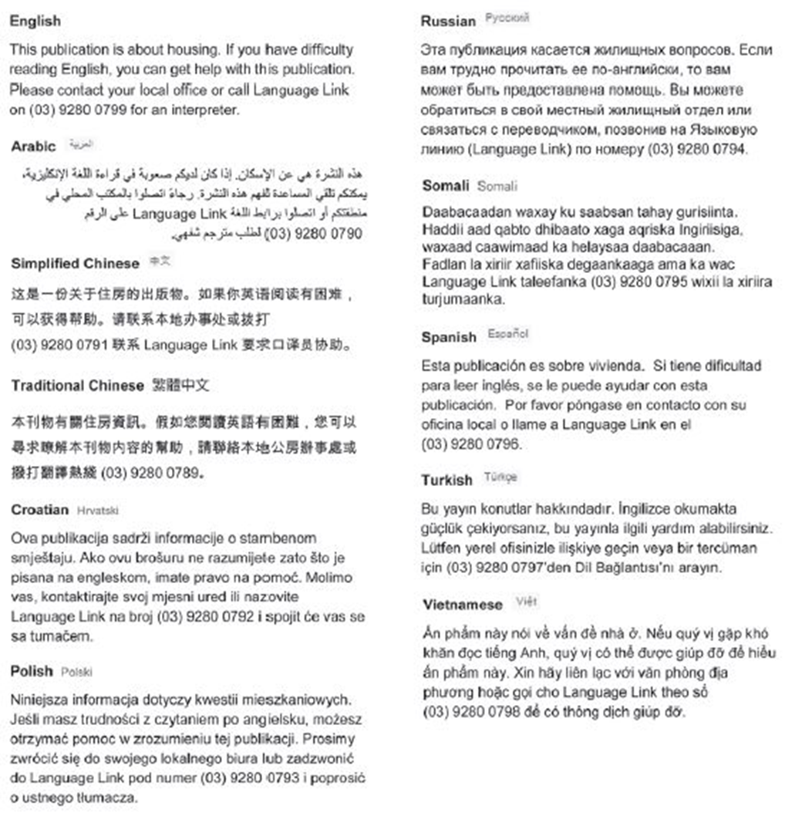

To receive this publication in an accessible format phone 1300 475 170, using the National Relay Service 13 36 77 if required or [contact your local office](http://housing.vic.gov.au/contact-a-local-office) <http://www.housing.vic.gov.au/contact-a-housing-office>.

Authorised and published by the Victorian Government, 1 Treasury Place, Melbourne.

© State of Victoria, Department of Health and Human Services, November 2017.

ISBN: 978-1-76069-131-8

Available at [Housing.vic’s Applying for a movable unit page](http://housing.vic.gov.au/applying-movable-unit) <http://housing.vic.gov.au/applying-movable-unit>